Lesson plan: Les animaux (Pets)

Lesson duration – 60 minutes

This lesson plan is for a Year 7 mixed ability class. It assumes little or no prior knowledge of French 'animal' vocabulary.

Students could be given vocabulary lists prior to the lesson (such as the katelanguages vocabulary and grammar booklet for the unit ‘Me, my family and friends’).

Activity 1 (max. 3 minutes)

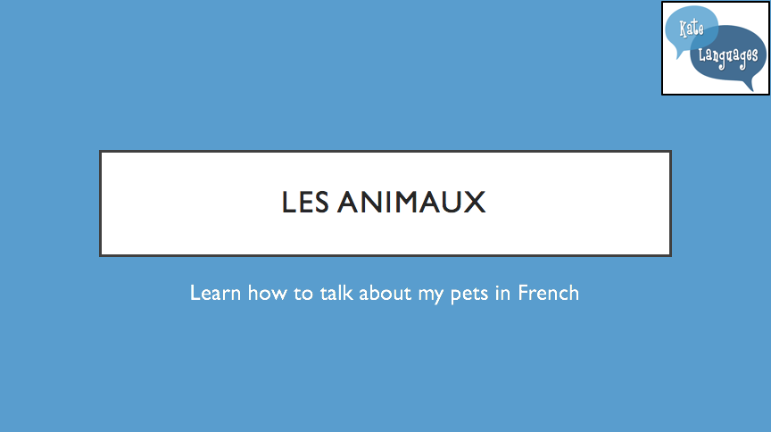

To check prior learning, the teacher asks if any students know the words for any animals in French. Students put up their hands and give max. one answer at a time. Teacher listens and corrects pronunciation where necessary.

Activity 2 (10-15 minutes)

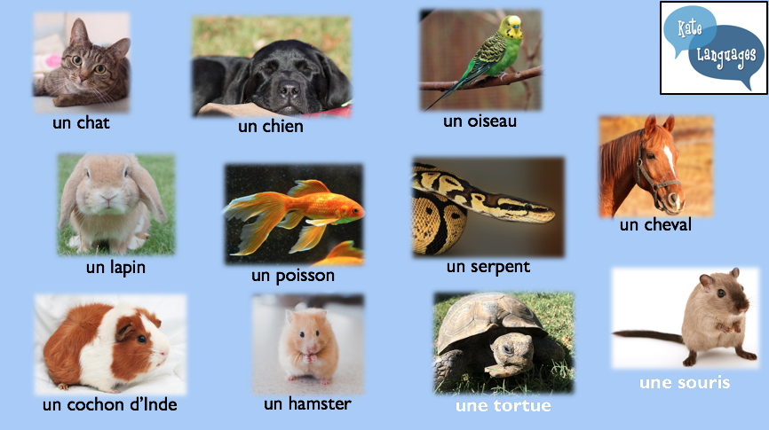

This slide can be exploited in a number of ways:
- Choral repetition. The teacher gives the name of each animal as it comes up (either with “j’ai …” or simply the name of the animal), students either stay silent or repeat after the teacher, then teacher repeats the names of the animals as the words come up underneath each picture.
- Play games to practise the vocabulary, such as beat the teacher, slap the board, bingo, etc. Rules for these games are at the end of this lesson plan.
- What’s missing? Copy and paste the slide, deleting the words and changing the animation so one picture disappears at a time. Students have to watch the board and either put their hands up to say which picture is missing or write on mini-whiteboards/scrap paper and show their answers to the class.

Activity 3 (max. 5 minutes)

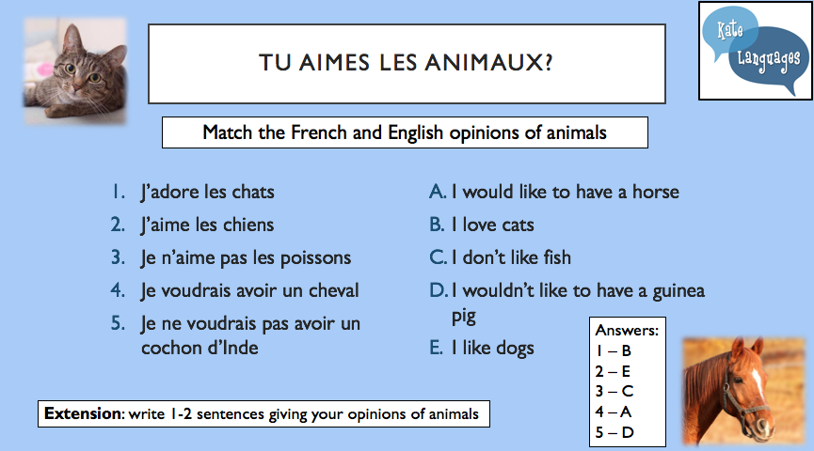

Students match the French and English sentences. Give time limit of 1-2 minutes, students write 1 – B, etc (not full sentences).
Check over the answers as a class, students mark their partner’s or their own work.

Activity 4 (10 minutes)

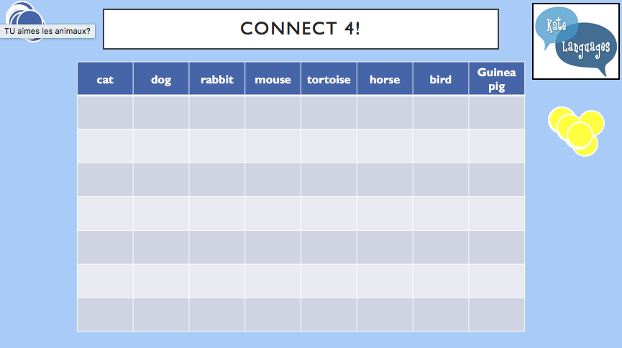

Students are split into two teams. To be allowed to place a coin on the Connect 4 grid, students must give their opinion (in French) of the animal named at the top of that column. Coins start at the bottom of the grid and build up (as in the game Connect 4). The winning team is the one who gets 4 in a row. This can take a long time sometimes, if students are very tactical, so give them a time limit for each answer!
I have found that this only works if you come out of full screen mode and manually move the coins to their positions. The other option is to draw on the coins (or let them choose a shape for each team such as a star or heart) as you go along, keeping it in full-screen mode.

Activity 5 (5 minutes)

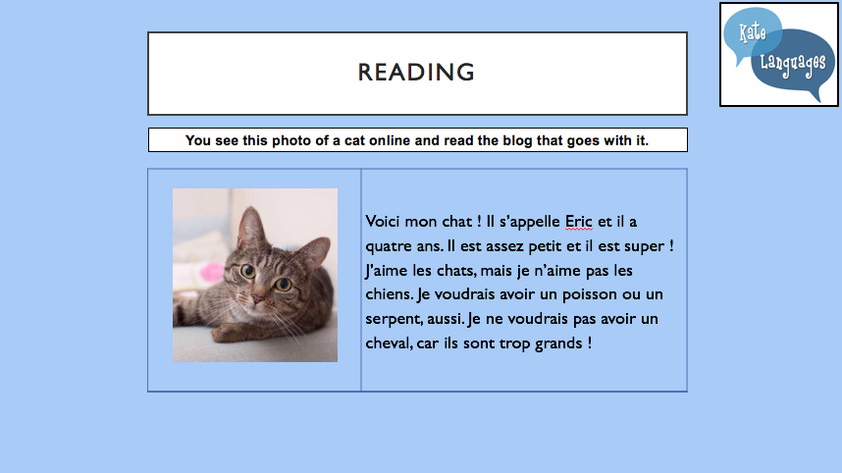

Hand out copies of the reading worksheet about Eric the cat and display the reading task on the board. Either get students to read the text aloud or on their own and then answer the questions. Set a time limit and then go through answers as a class.

Differentiation:

Some students may need more vocabulary support, so chunk the text up into separate sentences with one or two questions per sentence, like this:

Voici mon chat ! Il s’appelle Eric et il a quatre ans.

a) The cat’s name is:
A | Eric
B | Voici
C | Chat

b) How old is the cat?
A | 3
B | 4
C | 5

J’aime les chats, mais je n’aime pas les chiens.

c) What does the writer think of dogs?
A | She likes them
B | She doesn’t like them
C | She loves them

As an extension, quick finishers could think of 2 more comprehension questions to ask their partners/the rest of the class about the text.

Activity 6 (10 minutes)

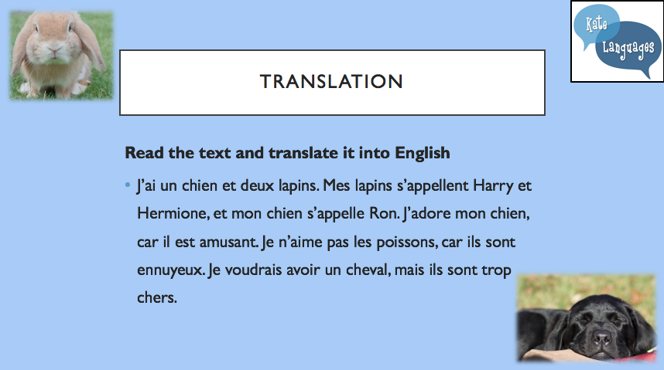

Hand out copies of the text to translate and display the text on the board. Give students a time limit to complete the translation.

Differentiation:

For learners who need the most support, chunk the text into sentences and give the English translation of the text in chunked sentences. Students have to match the French and English, like this:

French | English (in the wrong order !)
J’ai un chien et deux lapins. | I love my dog because he is funny.
Mes lapins s’appellent Harry et Hermione, et mon chien s’appelle Ron. | I would like to have a horse, but they are too expensive.
J’adore mon chien, car il est amusant. | I have a dog and 2 rabbits.
Je n’aime pas les poissons, car ils sont ennuyeux. | My rabbits are called Harry and Hermione, and my dog is called Ron.
Je voudrais avoir un cheval, mais ils sont trop chers. | I don’t like fish because they are boring.

For learners who need some support, chunk the text into sentences in a table and leave blank spaces for the translation, like this:
French | English
J’ai un chien et deux lapins.
Mes lapins s’appellent Harry et Hermione, et mon chien s’appelle Ron.
J’adore mon chien, car il est amusant.
Je n’aime pas les poissons, car ils sont ennuyeux.
Je voudrais avoir un cheval, mais ils sont trop chers.

Learners who need little support can translate the whole paragraph either on the sheet or in their exercise books.

Activity 7 (5 minutes)

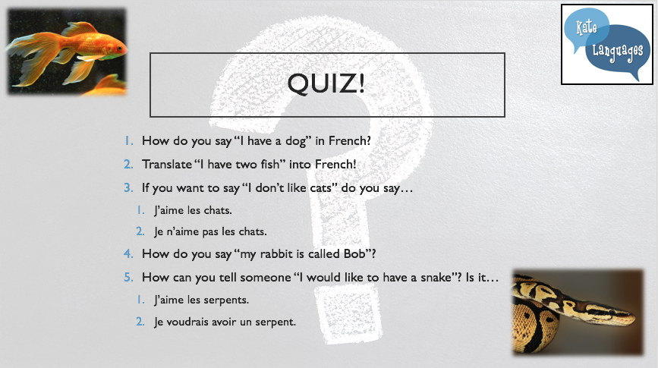

This can be done in a number of different ways:
1. Ask the class and pick one student to answer each question orally
2. Put the class into teams and get them to write the answers down on paper or mini-whiteboards. The team with the most correct answers wins.
3. Write the answers individually in their exercise books and check the answers together or when you next mark their books.
4. Write answers on a post-it or scrap paper with their name and hand in as they leave for you to check.

Games

Beat the teacher
The teacher points at a picture, says the name of the animal and the class repeat the name of the animal after him/her. Now and then, the teacher says the wrong animal for a picture that he/she is pointing at and the class must stay silent. If they repeat the word, the teacher gets a point, if they stay silent, they get a point. The winner is the first to 5 points.

Slap the board
Two students come to the whiteboard. Either give them a ruler each or let them use their hands. The teacher says a word and the first student to (gently) put their ruler (flat, not on the point!) or hand on the right picture gets a point. First to 5 again.

Bingo
Students draw a 3x3 bingo board in their books and fill in the squares with one of the animals in English. The teacher says the animal name in French and the students tick off each one as they hear it. The winners are the first to get a line, then the first to get a ‘full house’. The board would look similar to this:
cat | dog | horse
bird | guinea pig | tortoise
hamster | mouse | rabbit

